KEY MILESTONE 1 : CONCEPTUAL SCHEMA :



**CSE L: DBMS LAB**

Submitted By:

Muhammad Ibad Khan (22PWCSE2170)

Muhammad Maaz (22PWCSE2204)

Muhammad Talha Khan (22PWCSE2213)

Section: A

Submitted to : Engr . Sumayyea Salahuddin

Department of Computer Systems Engineering

University of Engineering and Technology Peshawar

Project title : Online Learning Platform(Edu-Port)

|  |  |
| --- | --- |
| **ATTRIBUTES** | **DESCRIPTION** |
| **Entity Name** | Edu-port |
| **Entity Type** | Online Learning Platform |
| **Founded** | 2025 |
| **Headquarters** | Peshawar , Pakistan |
| **Target Audience** | Students, professionals, educators, and lifelong learners |
| **Core Services** | Online courses, certifications, skill assessments |
| **Subjects Offered** | Technology, Business, Arts, Science, Health, Language, Personal Development |
| **Content Format** | Video lectures, interactive quizzes, Exercise,Explanation and Readings. |
| **Technology Used** | Frontend, Backend, Databases |
| **Revenue Model** | Premium model, subscriptions, course fees, institutional licensing |
| **Key Partners** | Universities, tech companies, industry experts, Education institutes |
| **Notable Features** | Personalized learning paths, certificates, discussion forums, live mentoring |
| **Languages Supported** | English |
| **Accreditation** | Some courses accredited by partner institutions |

**BUSSINESS RULES:**

**1.USER:**

Can be learner, instructor or both.

**2. Instructors and Courses:**

* One instructor can create many courses.
* Each course must be created by one instructor.
* A course must include learning content (videos,course_id, readings, or projects).

**3. Learners and Enrollments:**

* A learner can enroll in many courses.
* A course must have at least one learner
* Each enrollment links one learner to one course only.

**4. Certificates:**

* Learners receive a certificate after completing all course requirements.
* A certificate is linked to one learner and one course.

**5.Platform-Specific Rules:**

* Content is provided in English only (currently).
* Edu-port supports personalized learning paths and live mentoring.
* Only verified users can access certificates and premium features.
* Premium users get full course access; free users have limited content.
* Revenue comes from subscriptions, course fees, and institutional licensing.

**6. Learners:**

* A learner can enroll in multiple courses.
* Each enrollment links one learner to one specific course.
* Learners can track their individual progress in each course.
* A certificate is awarded to the learner upon successful course completion.

**ER Diagram:**

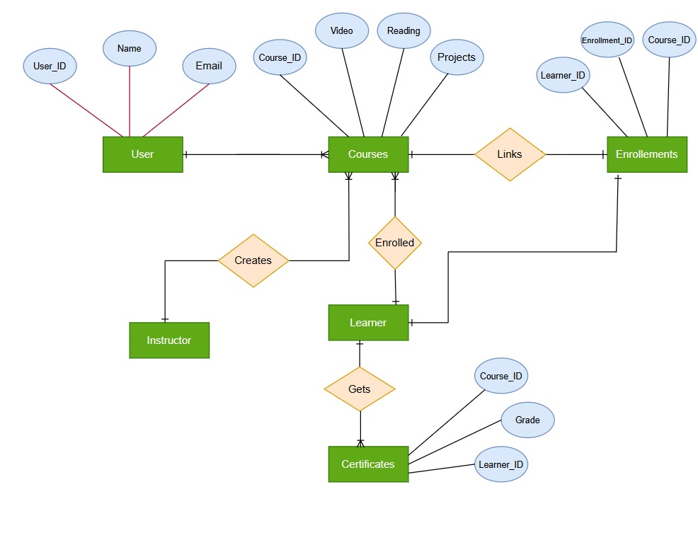

**Enhanced-ER Diagram:**

**Refrences:**

* Chatgpt
* Lecture Uploaded in Classroom (lec-2 , Lec -3).
* Draw.io for ER diagrams
* GitHub
* Google
* YouTube